**Signalling - operational changes**

The new signalling process for V0.9 of Open Rails introduces a number of operational changes which are detailed in this document.

Note that this document details behaviour while in Single player mode only.

For Multiplayer environment, different rules may apply, this is not yet defined.

## Control Mode

The new concept of Control Mode is introduced.  
This Control Mode defines what interaction there is between the player and the control system, and the level of control of the player on signals and switches.

There are two basic modes : Auto Mode and Manual Mode.  
Use the CTRL-M key to toggle between these modes.

**Auto Mode.**

In Auto Mode, the control system sets the train’s path and signals, and the player cannot change the setting of the switches or request for signals at danger to clear. The train’s route is taken from the path as defined in the Activity Editor, and the system will attempt to clear the route ahead of the train according to the signalling rules and interaction with other trains.

No route is cleared in reverse direction as the train is not assumed to run in reverse. Selecting a reverse cab or changing the position of the reverser does not change the direction of the route. In fact, the route will not be reversed other than at reversal points as defined in the train’s path. At these reversal points, the route will reverse automatically as soon as the train stops.

If the train does accidentally run backward, e.g. due to slipping or setting back after overshooting a platform, only safety checks are performed for the rear end of the train with respect to signals, switch alignment, other trains and end of track. There is no check on speedlimits behind the train.

Setting switches using F8 window or G/Shift-G is not allowed. Setting switches using ALT-mouseclick is possible, but not allowed for switches in the train’s path. However, any switches set manually will automatically be reset by an approaching train according to that train’s path. So, in Auto Mode the train can not deviate from the path as defined in the Activity Editor.

Request to clear a signal ahead of the train using the TAB command is only allowed when the track ahead is occupied by a another train which is at a stand-still, and when that track is in the train’s route. Request to clear a signal which would lead the train off it’s route is not allowed. Request to clear a signal behind the train using Shift-TAB is also not possible.

Auto Mode is intended for normal running under control of signals or traffic control. Shunt moves can be performed if fully defined in the train’s path, using reversal points etc.

There are two sub-modes to Auto Mode : Auto Signal and Auto Node.

Auto Signal is the normal mode on signalled routes. The train’s route is generally cleared from signal to signal. Only in specifically defined situations can routes be cleared short of a signal as detailed below.

Auto Node is set when the train has not encountered any signals yet, e.g. on unsignalled routes or at the start of the route when there is no signal along the path of the train as far as it can be cleared - e.g. in yards where the train starts but has no clear route yet to the first signal.

Auto Node can also be set if the route ahead cannot be fully cleared upto the next signal, and partial clearing is allowed.

A number of sub-states is defined in Auto Node, depending on the reason clearance is terminated. In the list below, (***A***) indicates a subtype which can occur if no signal has yet been encountered, (***B***) indicates a subtype when a route from a signal is partially cleared.

The following states are possible :

* *(****A****)* route ahead is clear to the maximum distance for which the track is cleared. The control mode is set to Auto Node - Max Distance.
* *(****A****)* route ahead is blocked at a switch which is aligned for and occupied or reserved by another train. Control mode is set to Auto Node - Misaligned Switch.
* *(****A****)(****B*** *- only if signal allows access to occupied track, or after TAB command)* route ahead is occupied by a stationary train or train moving in the same direction. Control mode is set to Auto Node - Train Ahead.  
    
  Note that, for (***A***), it should not be possible that the route ahead is occupied by a train moving in opposite direction - in that case, there should always be a misaligned switch in the train’s path.  
    
  For (***B***), signal will never clear when train ahead is moving in opposite direction, nor will the TAB request be granted.
* *(****A****)(****B****)* the train’s defined path terminates short of the next signal, or there is a reversal point short of the next signal, and there is at least one switch between this point and the next signal.  
  The control mode changes to Auto Node - End of Path.  
    
  Note that if there is no switch between the terminating or reversal point and the next signal the route is automatically extended to the next signal.
* *(****A****)(B)* the train has passed the last signal before the end of the track, or the train has reached end of track without encountering any signal. The control mode changes to Auto Node - End of Track.

Change between Auto Node and Auto Signal and v.v. is automatic and cannot be influenced by the player.

**Manual Mode.**

When it is required for a train to move of it’s defined path, a player can switch it’s train to Manual Mode. This will allow the player to set switches and request to clear signals off it’s path. However, there are a number of restrictions when running a train in Manual Mode.

In Manual Mode, a route is cleared from the train in both directions, ahead of and behind the train. The route is cleared to a shorter distance as compared to Auto Mode, and is never cleared automatically beyond the first signal. If a train is moving and passes a signal in opposite direction, the route behind the train will automatically retract to that signal as that is now the next signal in the reverse route. Similar, of course, when train is running in reverse with respect to signals ahead.

The route orientation will not change whatever direction the train is running. It is fixed to the orientation of the route as it was the moment the player switched to Manual Mode. So, changing to a reverse cab or changing the position of the reverser does not change the direction of the route orientation. This is no limitation on the train’s behaviour, as routes are always cleared in both directions. It does, however, affect the display of F4 and F8 windows, as the top/bottom direction of these windows is linked to the route direction and will therefore not change if the train reverses. To assist the player in his orientation in which direction the train is moving, an ‘eye’ has been added to these displays symbolizing the direction of the cabview, and an ‘arrow’ has been added to symbolize the direction of the reverser.

The player can set all switches in the train’s path using F8 window or the G/Shift-G keys. The G key will set the first switch ahead of the train (as according to the route direction), Shift-G sets the switch behind the train. It is also possible to set switches as required using the ALT-mouseclick command. Switches can be set even if they are in the train’s path and a signal has been cleared over that path. Switches can, of course, not be set if already set as part of a cleared route for another train.

The following rules apply to the setting of switches :

* all switches will remain in the position in which they were set by the last train passing over that switch. If no train has yet passed over the switch, it is in its default position.
* when in Manual Mode, trailing switches will not be automatically aligned for the approaching player train, **except** :
* when a route is cleared through a signal while in Manual Mode, any trailing switches in the train’s path upto the end of authority (e.g. next signal) will be aligned.  
  Note that in this case, trailing switches in the path cleared by the signal can no longer be reset.

Signals which the train approaches will not be cleared automatically. The player must request clearance of all signals encountered using the TAB or Shift-TAB keys.

The TAB key will clear the signal ahead of the train (according to the route direction), the Shift-TAB key will clear the signal behind the train.

Repeated use of (Shift-)TAB will clear the next signal beyond the first cleared signal etc., but only up to the maximum clearing distance.

Signals will always clear on request except when the section immediately behind the signal is already cleared for a train from the opposite direction. The normal route-setting limitations etc. are ignored. The signal will only clear to the first available most restrictive aspect above Stop.

Note that, in contrast to the situation in Auto Mode, as the signal will clear even if the full route behind the signal is not available, a cleared signal is no indication of the cleared distance beyond that signal. It may be that the first switch beyond the signal is already cleared for another train. Therefore, when in Manual Mode, use of F4 window to check on the route availability is essential when running in an area with AI traffic.

When in Manual Mode, deadlock prevention processing is switched off. This is because of the changes in the train’s route and direction which are likely to occur in Manual Mode could jeopardize the stability of the deadlock processing. So, care should be taken when using Manual Mode in an area with AI traffic, specifically on single track sections.

The only requirement to switch from Auto Mode to Manual Mode is that the train is at a standstill. The CTRL-M key toggles between Auto Mode and Manual Mode. When switching from Auto Mode to Manual Mode, all signals already cleared will be reset, and new routes are cleared ahead of and behind the train for the maximum distance if possible, or upto the first signal.

To switch back from Manual Mode to Auto Mode the front of the train must be on the path as defined in the Activity Editor. If the path contains reversal points, the train must be in between the same reversal points as where it was when it switched to Manual Mode (same subpath).

If the train is moving in the direction as the path defines, switch back to Auto Mode can be done while the train is moving. The rear of the train need not be on the defined path, only the front.

If the train is moving in the opposite direction, it must be at a standstill in order to switch back to Auto Mode. If the orientation of the train’s route somehow was reversed (e.g. by moving through a balloon-line or a Y-section) and differs from the direction in the defined path, both front and rear must be on the defined path. In this situation, the orientation will switch back to the direction as defined in the path.

**Out-of-Control Mode.**

This is a special mode. Normally, the player train should not be in this mode.

The out-of-control mode is activated when the player violates a security rule.  
Such incidents are :

* when the player train passes a signal at danger;
* when the player train passes over a misaligned switch;
* when the player train runs beyond the end of the authorized path.

Such actions will place the player train in out-of-control mode.

In this situation, the emergency brake is activated and maintained until the train is stopped. The player has no control over it’s train until it is at a standstill.

Once the train has stopped, the player can switch to Manual Mode to try to restore to a correct situation (e.g. set back to in front of the signal at danger, authorized path etc.). Once a normal situation has been restored, the player can switch back to Auto Node. If the action led the player train onto a section of track already cleared for another train, that train too is stopped.

**Explorer Mode.**

When Explorer Mode is started instead of an activity, the train is set to Explorer Mode.

The player has full control over all switches. Signals will clear as normal but signals can be cleared over routes which are not normally available using the TAB or ShiftTAB commands.

## Track Access rules

As there no longer is a dispatcher or authorize function, it is up to the trains to clear their own path. When in Auto Signal mode, part of that function is transferred to the signals.

In Auto Node mode, trains will clear their path upto 5000 meter, or the distance covered in 2 mins. at the max. allowed speed, whichever is furthest. In Auto Signal mode, the no. of signals cleared ahead of the train is taken from the value of the SignalNumClearAhead parameter as defined in the sigcfg.dat file for the first signal ahead of the train.

In Manual mode, the distance cleared is 3000 meter maximum, or as limited by signals.

Distances in Explorer mode are similar to those in Auto mode.

If a train is stopped at a signal it can claim the track ahead ensuring it will get priority as next train onto that section, but to avoid needless blocking of other possible routes, no claim is made if the train ahead is also stopped.

No distinctions are made between any type of train, and there are no priority rules.

## Deadlock Processing

When a train is started, it will check its path against all other trains (including those not yet started). If a section is found on which this train and the other train are due in opposite directions, the boundaries of that total common section are determined, and ‘deadlock traps’ are set at those boundaries, for each train in the appropriate direction. These boundaries are always switch nodes. When a train passes a node which has a ‘deadlock trap’ for that train, the trap is sprung. When a train approaches a node which has an active deadlock, it will stop at that node, or at the last signal ahead of it if there is one. This train will now also spring it’s deadlock traps, and will claim the full common section of that deadlock, to ensure it will be the next train allowed onto that section. The deadlock traps are removed when a train passes the end node of a deadlock section.

When a train is started, and the train’s path includes one more reversal points, deadlocks are only checked for the part of the path upto the first reversal point. On reversal, deadlocks are checked for the next part etc.

Deadlock traps are removed when a train switches to Manual mode. When the train switches back to Auto mode, the deadlock check is performed again.

There are no deadlock checks in Explorer mode as there are no AI trains when running in that mode.

If an alternative path is defined (using the Passing Path definition in MSTS Activity Editor), and the train is setting a route to the start node of this alternative path, it will check if a deadlock is set for the related end node. If so, and the alternative path is clear, it will take the alternative path, allowing the other train to use the main path. If the alternative path is already occupied, the train will wait short of the node where the path starts (or the last signal in front, if any); this is to prevent blocking both tracks which would leave the opposite train nowhere to go.

Further rules for use of the alternative paths :

* Trains from both direction must have the same main path through the area.
* If only one train has an alternative path defined, and trains are to pass, that train will always use the alternative path, the other train will always use the main path, regardless of which train arrives first.
* If both trains have an alternative path defined, and trains are to pass, the first train to clear it’s route will take the alternative path. Note that this need not always be the first train to arrive - it could be that the train which first clears it’s path takes much longer to actually get to the passing loop.

## Reversal Points

If a reversal point is defined, the path will be extended beyond that point to the end of the section, this is to the next switch or signal, or end of track.

The ‘diverging’ point is determined - this is the switch node where the reverse route diverges from the incoming route. From this point, a search is made for the last signal facing the reverse direction which is located such that the full train will fit in between the signal and the end of the path. If there is such a signal, this will become the ‘diverging’ point. In order for a train to be able to reverse, the rear of the train must be clear of this ‘diverging’ point.

When a train has cleared the ‘diverging’ point, the reversal will take place immediately as the train stops. Note that the train need not have reached the actual reversal point, nor that it needs to be clear of any switches between the ‘diverging’ point and the end of the path. The ‘diverging’ point is shown in the F4 trackmonitor window as the position which the front of the train must have reached to ensure the rear end is clear.

Double reversal points will generally work as in MSTS, except that the train must stop in the section containing the double reversal points.

Because reversal points are activated as the train is stopped clear of the diverging point, reversal points placed in the same section as the starting point (i.e. before the first signal or switch), are immediately activated on start of the activity. This also applies to double reserval points in such a position, which therefore don’t work as intended. This can be solved by placing a waiting point (with waiting time of 1 sec.) just after the reversal points; this waiting point now performs the function of blocking the train’s authority as intended. Note that this is only necessary for double reversal points placed immediately in front of the starting point.

## Signals at Station Stops

If the signal at the end of a platform protects a route which contains switches, that signal will be held at danger upto 2 mins. before booked departure. If the station stop is less than 2 mins., the signal will clear as the train comes to a stand. This applies to both AI train and player trains.

However, if the platform length is less than half the train length, the signal will not be held but will clear as normal to allow the train to properly position itself along the platform. Signals which only protect plain track will also not be held.

Signals at waiting points for player trains will be held at danger until the train has stopped. For signals at waiting points for AI trains, see chapter on AI train control.

## Speedposts and speed lmits set by Signals

Speedlimits which raise the allowed speed, as set by speedposts or signals, only become valid when the rear of the train has cleared the position of speedpost or signal.

When a speedlimit set by a signal is lower than the speedlimit set by the last speedpost, the speedlimit is set to the lowest value. However, when a speedlimit as set by a signal is higher than the present speedlimit set the last speedpost, the limit of the speedpost will be maintained. If a lower speedlimit was in force due to a limit set by another signal, the allowed limit is set to that as defined by the speedpost.

If a speedpost sets a limit which is higher than that set by the last signal, the limit set by the signal is overruled and the allowed limit is set to that as defined by the speedpost.

## Display Windows

The windows displayed by F4 (TrackMonitor), F8 (Switch Control Window) and F9 (Train Control Window) have been adapted to the new modes as detailed above.

**The trackmonitor window, displayed using F4**.

This window has two different layouts according the the train’s control mode : Auto mode or Manual mode / Explorer mode.

Display in Auto mode :

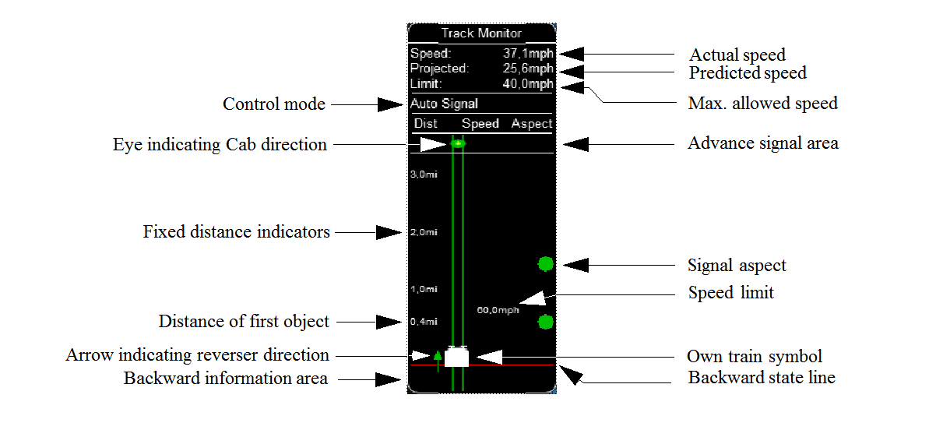

Display in Manual mode / Explorer mode:

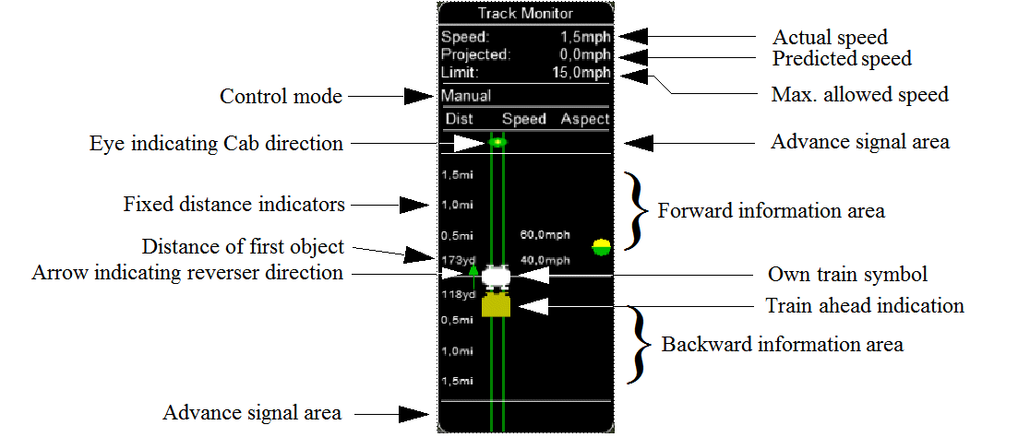

Displayed symbols (common for Auto and Manual mode unless indicated otherwise) :

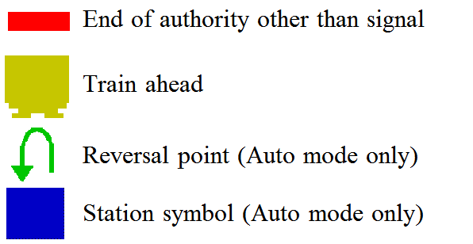

Notes :

* Distance value is displayed for first object only, and only when within distance of first fixed marker.  
  Distance is not shown for next station stop.
* When no signal is within the normal display distance but a signal is found at a further distance, the signal aspect is displayed in the advance signal area. The distance to this signal is also shown.  
  This only applies to signals, not speedpost.
* For Auto mode :  
  if the train is moving forward, the line separating the Backward information area is shown in red, and no Backward information is shown.  
  If the train is moving backward, the separation line is shown in white, and Backward information is shown if available.
* For Manual mode :  
  if the train is on it’s defined path (and toggle back to Auto control is possible), the own train symbol is shown in white, otherwise it is shown in red.
* The colour of the track-lines are an indication of the train speed with regards to the maximum allowed speed :
* Dark green : low speed, well below allowed maximum
* Light green : optimal speed, just below maximum
* Orange : slight overspeed but within safety margin
* Dark red : serious overspeed, danger of derailment or crashing

Note that the placement of the objects with respect to the distance offset is indicative only. If multiple objects are placed at short intermediate distances, the offset in the display is increased such that the texts do not overlap. As a result, only the first object is always shown at the correct position, all other objects are as close to their position as allowed by other objects closer to the train.

**Switch control window, activated by F8.**

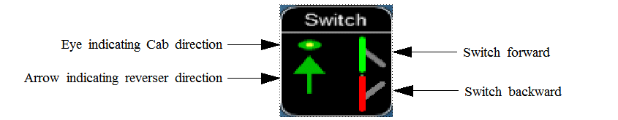

Switch shown in green can be operated, switch shown in red is locked.

Switches shown in red can not be set by the player.

**Train control window, activated by F9.**

In the train control window, the unit which the player has selected as the unit from which to control the train, i.e. the lead unit, is shown in red.

The following changes have been made to AI train control :

* AI trains always run in Auto control mode.
* AI trains will ignore any manual setting of switches and will reset all switches as defined in their path.
* AI trains will stop at stations and will adhere to the booked station departure times if possible.
* AI trains will stop at a platform such that the middle of the train stands in the middle of the platform. If the train is longer than the platform, it means both front and rear of the train will stand outside the platform. If the platform has a signal at the end, and this signal is held at danger (see above), and the train is too long for the platform, it will stop at the signal. But if the train length is more than double the platform length, the signal will not be held.
* AI trains will adhere to the speed limits.
* AI trains will stop at signal at approx. 30 m. short of a signal at danger.
* At waiting points, the AI trains will stop at the next stopping position, i.e. short of the next switch or next signal. Any signal beyond the waiting point is kept at danger until the required departure time.
* Where AI trains are allowed to follow other trains in the same section passing permissive signals, the train will adjust it’s speed to that of the train ahead, and follow at a distance of approx. 300m. If the train ahead has stopped, the train behind will draw up to a distance of about 50m. However, if the train ahead is stopped in a station, and the train behind is also booked to stop at that station, the train will draw up behind the first train up to a distance of a few meter.
* The control of AI trains before the start of an activity is similar as to the normal control during an activity, except that the update frequency is reduced from the normal update rate to just once per second. But all rules regarding speedlimits, station stops, deadlock, interaction between AI trains (signals etc.) are followed. The position of all AI trains at the start of an activity therefore is as close as possible to what it would have been if the activity had been started at the start time of the first AI train.